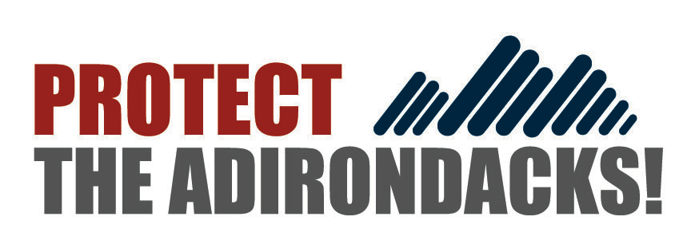

PRESS RELEASE
August 29, 2023

Protect the Adirondacks Calls on Governor Hochul
To Release Adirondack Salt Reduction Task Force Report

Long delayed and overdue report needs to be released before
new 2023-24 winter and road salt season begins

For more information:
Peter Bauer, Executive Director: Cell 518.796.0112

North Creek, NY— Protect the Adirondacks today called for Governor Kathy Hochul to release the long stalled Adirondack Road Salt Reduction Task Force report. In December 2020, the Randy Preston Road Salt Reduction Act was signed into law, creating the Adirondack Road Salt Reduction Task Force. The Task Force was organized in 2021, led by Department of Environmental Conservation (DEC) and Department of Transportation (DOT), and completed its deliberations by late 2022. As a new winter and road salt season approaches there has been no news or public information about the report, which has apparently been drafted for months.

Salt pollution is well documented in a number of Adirondack lakes. Lake George has seen a tripling of salt pollution in the last three decades. Many other lakes, from Blue Mountain Lake to Lower Saranac Lake to White Lake to the Caroga Lakes to Mirror Lake are experiencing salt pollution. A recent study found dozens of residential private wells polluted and contaminated by salt used for winter roads management.

“It's intolerable that many of the Adirondack Park’s grandest lakes are polluted by road salt. The intolerable shouldn’t be tolerated. The Adirondack Road Salt Reduction Task has had enough time. Adirondack communities must not be made to continue to wait another winter and continue to endure salt pollution as usual with no action,” said Peter Bauer, Executive Director of Protect the Adirondacks. “We urge Governor Hochul to demand that the Adirondack Road Salt Reduction Task report is finalized and released as soon as possible.”

Salt pollution in Adirondack waters is unquestioned. Across the Adirondacks, it is estimated that 193,000 tons of salt are put down on state and local roads each winter, about 110,000 tons on state roads alone. The NYS DOT applies on average over 23 tons of salt per lane kilometer on state roads annually.

The data from various long-term research projects has proved the case and shown the impacts of road salt pollution to Adirondack waters. Protect the Adirondacks and the Paul Smith’s College Adirondack Watershed Institute are in their 26th year of a partnership monitoring lakes and ponds across the Adirondack Park through the Adirondack Lake Assessment Program (ALAP). This program has compiled a long-term dataset of over 70 lakes that is invaluable because it provides 25-year trend lines about the water quality of many major representative lakes and ponds across the Adirondacks. ALAP is a key source of road salt pollution data in the Adirondack Park along with the Lake George Association (LGA)/RPI Darrin Fresh Water Institute’s long-term study of Lake George.

See a letter sent to Governor Hochul here: https://www.protectadks.org/wp-content/uploads/2023/08/230829-Hochul-Salt-Task-Force.pdf

Protect the Adirondacks

Protect the Adirondacks is an IRS-approved non-profit organization dedicated to the preservation and stewardship of the 6-million-acre Adirondack Park. Our mission is to protect the Adirondack Park’s wild character for current and future generations. PROTECT pursues this mission through a combination of advocacy, grassroots organizing, independent public oversight, research, water quality monitoring, education, and legal action. Protect the Adirondacks was formed in 2009 as the result of a merger between two long-standing environmental conservation groups in the Adirondack Park, the Resident’s Committee to Protect the Adirondacks (est. 1991) and the Association for the Protection of the Adirondacks (est. 1901).

Protect the Adirondacks is managed by a 21-member Board of Directors of Adirondack leaders with expertise in environmental law, local government, Adirondack environmental and cultural history, state agency management, and small business. Protect the Adirondacks maintains an office in a 100% energy efficient, solar-and wind-powered office in Johnsburg in the central Adirondacks. For more information see www.protectadks.org and @ProtectAdkPark.

##

